Edo Blood II
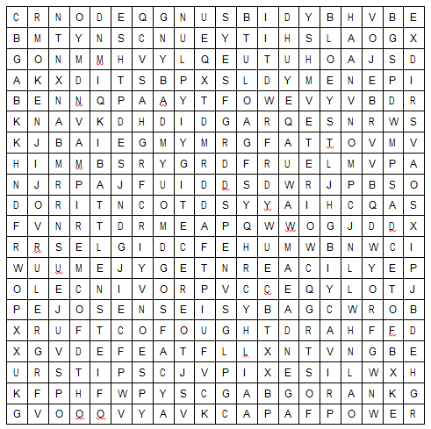
All the words below can be found in the wordsearch grid above. They might be written forwards, backwards, up, down or diagonally. Can you find them all?

AGENDA
BATTLE
BLOOD
CHINA
CREATURE
DEFEAT
EDO
ENEMY
FORMIDABLE
FOUGHT
GOAL
HOME
KENJI
MITSUI
POWER
PRIVACY
PROVINCE
QIN DAO
RULER
SENSEI
STUDY
SUNG
VAMPIRE
WARLORD
WARRIOR
YEARS

